Callus induction and plant regeneration in Lychnis wilfordii (Regel) Maxim, an critically endangered plant in Korea

Kee Hwa Bae¹, Mi Hyun Lee, Yong Eui Choi³, Eui Soo Yoon⁴*

¹National Institute of Biological Resources, 42 Hwangyeong-ro, Seo-gu, Incheon, 404-708, Republic of Korea
²R&D center, Asiaseed Co. Ltd., Icheon, 447-2, Gyeonggi Province, Republic of Korea
³Division of Forest Resources, College of Forest and Environmental Sciences, Kangwon National University, Chunchon, Kangwon-do 200-701, Republic of Korea
⁴Department of Biology, College of Nature Sciences, Kongju National University, Kongju 314-701, Republic of Korea

* For correspondence

Eui-Soo Yoon

Department of Biology, College of Nature Sciences, Kongju National University, Kongju 314-701, Republic of Korea
Tel: 82-41-850-8502
Fax: 82-41-850-8510
E-mail: yes@kongju.ac.kr

No. of Table: 2
No. of Figure: 2

Callus induction and plant regeneration in Lychnis wilfordii (Regel) Maxim, an critically endangered plant in Korea

Kee Hwa Bae¹, Mi Hyun Lee, Yong Eui Choi³, Eui Soo Yoon⁴*

¹National Institute of Biological Resources, 42 Hwangyeong-ro, Seo-gu, Incheon, 404-708, Republic of Korea
²R&D center, Asiaseed Co. Ltd., Icheon, 447-2, Gyeonggi Province, Republic of Korea
³Division of Forest Resources, College of Forest and Environmental Sciences, Kangwon National University, Chunchon, Kangwon-do 200-701, Republic of Korea
⁴Department of Biology, College of Nature Sciences, Kongju National University, Kongju 314-701, Republic of Korea

Abstract

Lychnis wilfordii (Regel) Maxim is a rare and valued ornamental plant. Since seed propagation has not been regarded as a proper method for in vitro germination and propagation of this species. Germination rate reached 46.6% when seeds were treated with 100 mg l⁻¹ GA₃. The highest callus induction was observed in the leaf explants of the seedlings on MS medium containing specific concentrations of 0.5 mg l⁻¹ BA and 3.0 mg l⁻¹ NAA. The adventitious shoot was formed 97.3% of calli on 1/2 WPM medium. The plantlets grew well after transferring to the pot. The height of in vitro propagated plantlets was no difference among regenerated medium. This in vitro propagation protocol should be useful for conservation of this endangered plant.

Key words: callus, endangered plant, In vitro germination, L. wilfordii

Introduction

The genus Lychnis belongs to the family Caryophyllaceae and consists of about 30 species in the world. Lychnis spp. are distributed throughout the temperate regions of the Northern Hemisphere, from East Asia to Europe (Magnus et al. 2008), and 4 Lychnis spp. are native to Korea (Lee 1974). Some species of Lychnis spp. are frequently grown in Korea for horticultural use.
Lychnis wilfordii (Regel) Maxim is a perennial and narrowly distributed in Kangwon province of Korea. Also, it is rare and critically endangered species which is subjected to strict protection as an endemic plant. The population size declines rapidly. For this reason, the Ministry of Environment (MEV) has designated the species as ‘Threatened to extincts : the second grade for preservation’ (Lee and Choi 2006). Also, this species reproduction by seeds is rarely used due to poor seed germination and low seed production.
L. wilfordii is a valued ornamental plant with orange-red flowers. However, little attention was paid to this material by Korean botanists and horticulturists. The main reason for this is the limitation of suitable environments and low productivity of the species. In nature, the species propagates through seed and vegetative perennial rootstock. According to our preliminary investigations on propagation of L. wilfordii via seed, we found that seed germination took 2–3 months and was sporadic from ex vitro or in vitro culture. Meanwhile, vegetative propagation was not possible as the process of rooting was too slow. Therefore, the development of an in vitro protocol will be of great importance for conservation and sustainable utilization of this species. However, propagation protocols for this species in vitro have not yet been reported.
The purpose of this study of L. wilfordii in vitro propagation methods was to improve the germination rates of seeds and develop a protocol for in vitro propagation via organogenesis.

Materials and Methods

Seeds of L. wilfordii were collected from a wild population of Mt. Odae National Park in Korea late September of 2010. Mature seeds of L. wilfordii were scarified by immersion in 70% EtOH for 1 min and then sterilized with sodium hyporchloride (NaOCl) 1% (v/v) (5% of sodium hypochlorite, Sigma, USA) with a few drops of Tween-20 (Sigma, USA) for 30 min. For the GA₃ treatment, seeds were soaked in 100 mg l⁻¹ GA₃ solution for 24h before incubation. The seeds were washed 5 times in sterile water and placed into petri-dishes containing hormone-free MS (Murashige and Skoog 1962) medium under white fluorescent lights (30 μmol m⁻² s⁻¹) on a 16 h photoperiod or in the dark at 25°C. The germination rate was tested after 8 weeks of culture. Thirty seeds were incubated for each treatment and repeated five times, and the seeding used in subsequent experiments.
After cutting the leaf, stem and root explants into 10 mm in sizes, they were cultured on MS medium supplemented with auxins (0, 1.0 and 3.0 mg l⁻¹ NAA : a-naphthalene acetic acid, 0, 1.0 and 3.0 mg l⁻¹ IAA : indole acetic acid ) and/or cytokinin (0, 0.5 mg l⁻¹ BA : N⁶-benzyladenine). All media were supplemented with 30 g l⁻¹sucrose and solidified with 8.0 g l⁻¹ plant agar, and then adjusted to pH 5.8 before autoclaving at 121°C for 20 min. Calli were maintained under cool white fluorescent lights (30 μmol m⁻² s⁻¹) on a 16 h photoperiod at 25°C. The frequency of callus induction was evaluated after 12 weeks of culture. Thirty explants (leaf, stem and root) were incubated for each treatment and repeated five times.
Calli were transferred to WPM (Lloyd and McCown 1980), half-strength WPM, one-third strength WPM medium and MS, half-strength MS, and one-third strength MS medium for the growth of plantlets. The culture room was maintained at 25°C with a 16 h photoperiod under 30 μmol m⁻² s⁻¹ white fluorescent light. Adventitious shoot formation rate was evaluated by counting plantlets with well-developed shoot primordia after 4 weeks of culture. And, plants with better roots were transplanted into a mixture composed of vermiculite and pealrite (1:1) in the single pot. Plantlet height was evaluated by measuring average length of shoots and roots after 4 weeks of culture.
All data were analyzed using ANOVA and expressed as means ± standard error (SE). To examine significant differences among the treatments, multiple comparison tests were then performed by Duncan’s multiple range test at p ≤ 0.05 (SAS 2001).

Results and Discussion

The germination rate of seeds was increased with GA₃ treatment as shown in Fig. 1. The germination rate reached 46.6% when seeds were treated with 100 mg l⁻¹ GA₃. However, the germination rate was still not sufficient for production of the species by seed propagation. Therefore, in vitro propagation of L. wilfordii was performed in the subsequent experiments.
Based on our preliminary study, L. wilfordii seeds have a poor and unpredictable germination rate. The result suggested that L. wilfordii seeds have deep dormancy. It has been reported that approaches to break seed dormancy such as hormonal, temperature, etc. are necessary (Seiler 1998, Mabberley 1989). Endogenous GA₃ has been widely studied in relation to the breakage of seed dormancy in various plant species. GA₃ treatment was resulted in improve germination of many plant species (Nicolas et al. 1996, Rehman and Park 2000). In the present study, it was found that the germination rate was increased in of GA₃ treated seeds comparison to the control treatments.
Callus formation varied significantly depending on kind of explants and plant growth regular (PGR) of L. wilfordii (Table 1). When explants were cultured on medium with BA, callus formation was more efficient compared to the explants without BA treatment. And the frequency of callus formation was higher on medium with NAA than on IAA (Table1). Leaf explants formed callus after 8 weeks of culture, but stem and root generated callus from cut surfaces after 10 weeks of culture. Calli of leaf (Fig. 2B) and root (Fig. 2C) were compact, globular and yellowish on MS medium with both 0.5 mg l⁻¹ BA and 3.0 mg l⁻¹ NAA after 12 weeks of culture, but control (non-treated PGR) did not form callus (Table 1). The frequency of callus formation leaf explants showed that the highest frequency (86.6%) of callus formation was obtained when the medium was supplemented with both 0.5 mg l⁻¹ BA and 3.0 mg l⁻¹ NAA after 12 weeks of culture. However, stem and root explants exhibited 73.3% and 12.7% callus formation, respectively (Table 1). Therefore, basal plate was the best explant for differentiating callus, and this result agreed with a previous report in garlic (Luciani et al. 2006). Callus induction in monocots requires long time for its initiation (Geier 1986). It was reported that the induction of callus was difficult and the proliferation of initiated callus was very slow and somehow difficult to maintain in other allium species (Zheng et al. 1998, Luciani et al. 2006).
To determine adventitious shoot induction from callus, both types of callus (compact and friable ones) were transferred onto media (WPM, 1/2WPM, 1/3WPM, MS, 1/2MS, and 1/3MS). After 20 to 25 days of culture, calli turned greenish (Fig. 2D) and several adventitious shoot regenerated on 1/2MS medium (Fig. 2E). The highest adventitious shoot induction rate was obtained in 1/2WPM medium (99.3%) (Table 2). However, there was not a remarkable difference on the growth of plantlets among the six media. The height of in vitro propagated plants in pot was around 20~35 cm (Fig. 2F). The variations of callus induction on different media may be due to the differences of NO₃/NH₄⁺ ratio, an important factor on nitrogen uptake and pH regulation during plant tissue culture (Fracago and Echeverrigaray 2001). Lower NO₃/NH₄⁺ ratio in B5 medium stimulated callus initiation and growth from other allium species (Gamborg et al. 1968, Chu et al. 1975, Luciani et al. 2001). In vitro culture technique is an alternative ways for germplasm conservation and micropropagation of valuable endangered plants. It has the advantages of preserving healthy plant material in a small space, easy and rapid multiplication for international exchange as well as cost reduction. Generally, addition of BA to the medium could induce the formation of adventitious buds. In the present study, the multiplication coefficient rose with the treatment of BA and NAA, respectively, but there was no interactive effects of BA and NAA.
However, in the present study, we established the tissue culture system to propagate the L. wilfordii and this technique may be applicable to commercially propagated the endangered L. wilfordii speices.

Acknowledgements: This work was supported by the research grant of the Kongju National University in 2012

References

Chu C.C., Wang C.C., Sun C.S. (1975) Establishment of an efficient medium for anther culture of rice through comparative experiments on the nitrogen sources. Sci. Sin. 18: 659-668.
Fracago F., Echeverrigaray S. (2001) Micropropagation of Cunila galioides, a popular medicinal plant of south Brazil. Plant Cell Tissue Organ Cult. 64, 1-4.
Gamborg O., Miller R., Ojima K. (1968) Nutrient requirements of suspension cultures of soybean root cells. Exp. Cell Res., 50: 151-158.
Geier T. (1986) Anthurium. In: Evans, P.V., Sharp, D.A., Bajal, Y.P.S. (Eds.), Handbook of Plant Cell Culture, vol. 5. Collier Macmillan/Macmillan, New York/London, pp, 228-252.
Lee Y.N. (1974) New taxa on Korean flora (1). Korea Journal of Botany, 17: 33-35.
Lee J.S., Choi B.H. (2006) Distribution and red data of wild orchids in the Korean Peninsula. Korea Jounal of Plant Taxon, 36: 335-360.
Lloyd E., McCown B. (1980) Commercially feasible micropropagation of mountain laurel (Kalmia latifolia) by use of shoot tip culture. Comb. Proc. Int. Plant Prop. Soc, 30: 421-427.
Luciani G.F., Mary A.K., Pellegrini C., Curvetto N.R. (2006) Effects of explants and growth regulators in garlic callus formation and plant regeneration. Plant Cell Tissue Organ Cult. 87: 139-143.
Magnus P., Abel G., Sileshi N., Jan S., Christian B. (2008) Colonization and diversification in the African ‘sky islands’ by Eurasian Lychnis L. (Caryophyllaceae). Journal of Biogeography, 35: 1016-1029.
Mabberley D.J. (1989). The plant-book: a portable dictionary of the higher plants. Cambridge: Cambridge University Press.
Murashige T., Skoog F. (1962) A revised medium for rapid growth and bioassays with tobacco tissue culture. Physiol. Plant, 15: 473-497.
Nicolas C., Nicolas G., Rodriguez D. (1996) Antagonistic effects on abscisic acid and gibberellic acid on the breaking of dormancy of Fagus sylvatica seeds. Physiol. Plant, 96: 244-250.
Rehman S., Park I.H. (2000) Effect of scarification, GA and chilling on the germination of golden rain-tree (Koelreuteria paniculata Laxm.) seeds. Sci. Hort, 85: 319-324.
SAS. (2001) SAS/STAT User’s guide (8.02) SAS Institute Inc., Cary, NC, USA.
Seiler G.J. (1998) Seed maturity, storage time and temperature, and media treatment effects on germination of two wild sunflowers. Agron. Journal, 90: 221- 226.
Zheng S.J., Henken B., Sofiari E., Jacobsen E., Krens F.A., Kik C. (1998) Factors influencing induction, propagation and regeneration of mature zygotic embryo-derived callus from Allium cepa. Plant Cell Tissue Organ Cult., 53: 99-105.

Table 1. Effects of NAA and IAA in combination with BA on callus formation from leaf, stem and leaf explants of L. wilfordii. MS medium containing 30 g l⁻¹ sucrose. Data were collected after 12 weeks of culture. Data are the means ± SD, of five time experiments, n=30. Different alphabetical letters are significantly different according to Duncun's multiple range test at P≤ 0.05.
PGR’s (mg l⁻¹) |  |  |  | Callus formation (%)
BA | NAA | IAA |  | Leaf | Stem | Root
0 | 0 | 0 |  | 0 | 0 | 0
0 | 1.0 | 0 |  | 33.3±5.3 e | 22.7±4.3 e | 8.7±3.8 ^{ab}
0 | 3.0 | 0 |  | 34.7±5.1 e | 30.0±5.3 ^{d} | 9.3±2.8 ª
0 | 0 | 0 |  | 0 | 0 | 0
0 | 0 | 1.0 |  | 30.0±5.3 e | 26.7±5.3 ^{d} | 11.3±3.8 ª
0 | 0 | 3.0 |  | 33.3±6.2 e | 28.7±3.8 ^{d} | 13.3±5.3 ª
0.5 | 0 | 0 |  | 0 | 0 | 0
0.5 | 1.0 | 0 |  | 80.7±9.5 ^{b} | 71.3±8.7 ª | 11.3±3.8 ª
0.5 | 3.0 | 0 |  | 86.6±4.3ª | 73.3±11.8 ª | 12.7±4.9 ª
0.5 | 0 | 0 |  | 0 | 0 | 0
0.5 | 0 | 1.0 |  | 52.0±9.6 ^{d} | 48.0±3.8 ^{c} | 13.3±4.7 ª
0.5 | 0 | 3.0 |  | 67.3±5.5 ^{c} | 64.7±5.6 ^{ab} | 14.0±4.9 ª

Table 2. Effect of various kinds of medium on adventitious shoot formation and plantlet conversion of L. wilfordii from callus. Adventitious shoot formation (%) was collected after 8 weeks of culture. Plantlet conversion was collected after 12 weeks of culture. Data are the means ± SD, of five time experiments, n=30. Different alphabetical letters are significantly different according to Duncun's multiple range test at P≤ 0.05.
Media | Adventitious shoot formation (%) | Plantlet conversion
Media | Adventitious shoot formation (%) | Length of shoot (cm) | Length of root (cm)
WPM | 82.0±6.5^{cd} | 12.0±1.6ª | 3.0±0.7^{b}
1/2WPM | 99.3±1.5ª | 13.0±1.0 ª | 2.8±0.8^{c}
1/3WPM | 96.7±4.7^{ab} | 12.6±1.5 ª | 2.8±0.8^{c}
MS | 86.7±5.3^{c} | 13.0±1.0 ª | 3.4±1.1ª
1/2MS | 97.3±4.3^{ab} | 12.4±1.1 ª | 3.0±0.7^{b}
1/3MS | 97.3±4.3^{ab} | 12.0±1.0 ª | 3.4±0.9ª

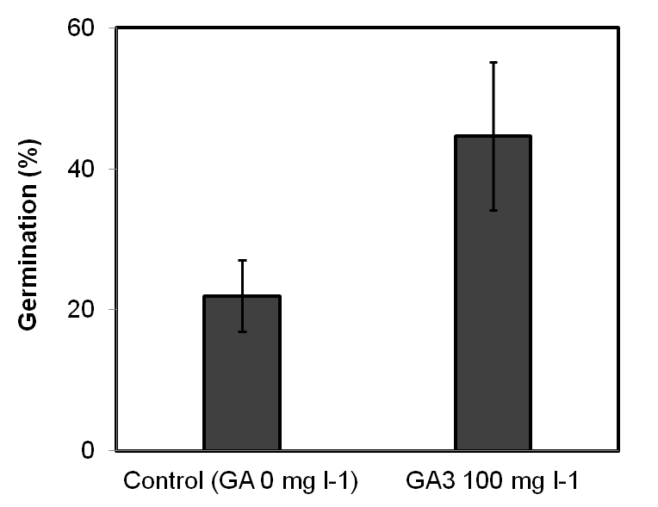
Fig. 1. Effect of GA₃ on germination of L. wilfordii: Thirty seeds were incubated for each treatment with five replicates. Germination rate (%) was recorded after 4 weeks of culture.

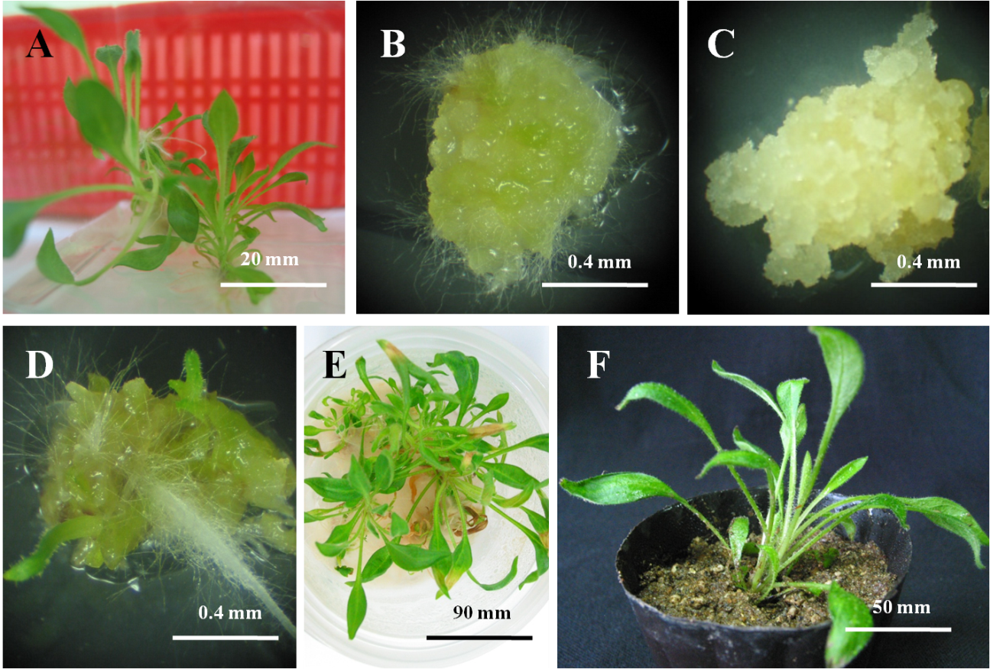
Fig. 2. Plant regeneration from callus derived from L. wilfordii. In vitro seedling of L. wilfordii (A). Initiation of callus induction from leaf explants on MS medium with 0.5 mg l⁻¹ BA and 3.0 mg l⁻¹ NAA (B). Initiation of callus induction from root explants on MS medium with 0.5 mg l⁻¹ BA and 3.0 mg l⁻¹ NAA (C). Conversion of shoot and root on 1/2MS medium without PGR’s after 4 weeks of culture (D). Proliferation of shoots on 1/2MS medium without PGR’s after 8 weeks of culture (E). Plantlet in sterile soil, vermiculite and pealrite (1:1) mixure for 10 day (F).

